Supercapacitors

* Also known as: Electrochemical capacitors.
* Use high surface area electrodes and thin electrolytic dielectrics.
* Advantages:
* Higher energy density than regular capacitors.
* More charge/discharge cycles than batteries.
* Faster charging/discharging.
* Efficiency and high storage capacity.

Principles of energy storage in SC

* Supercapacitors have self-discharging and unlimited cycles.
* Can be connected in series to generate high voltage.
* Works using a double-layer electrolyte capacitor concept.
* Charge up to a voltage limit; excessive voltage may damage it.
* Over-voltage protection by adding a resistor in series.

EDLC (Electrostatic double layer capacitors)

* Made of two similar carbon-based electrodes, an electrolyte, and a separator.
* They store energy electrostatically (non-Faradaic process), without any chemical reaction.
* 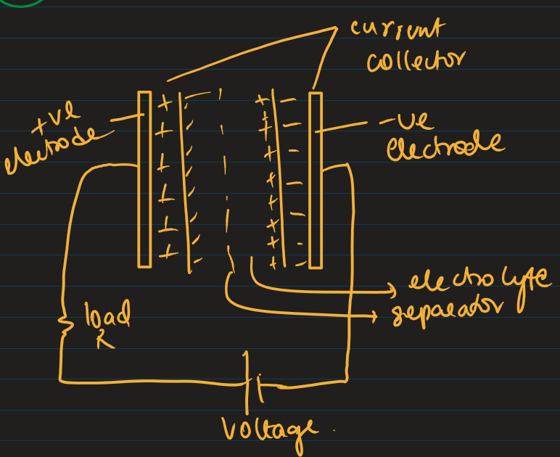
* Voltage causes charge to accumulate on the surface of the electrodes.
* This is followed by a natural attraction of unlike charges, ions in electrolyte solution diffuse across the separator into the pores of the electrode of opposite charge.
* Electrodes are designed to avoid recombination of ions.
* This creates an double-layer at each electrode.
* There is no direct charge transfer between electrode and electrolyte.
* The separator prevents recombination of ions and enables ion diffusion.
* These double layers are coupled with high surface area and small distance between layers to achieve high energy density.
* No chemical reactions result in high reversibility and very high cycling stability.
* Performance can be tuned by changing the nature of the electrolyte.
* DLCs can use: Aqueous electrolytes (e.g., H₂SO₄, KOH): Lower pore size requirement. [OR] Organic electrolytes (e.g., acetonitrile): Often used with larger voltage windows.

Electrochemical Pseudo Capacitor

* Uses metal oxide or conducting polymer electrodes with high amount of electrochemical pseudo capacitance additional to the double layer capacitance.
* Achieved by Faradic electron charge transfer with redox reactions, intercalation or electro sorption.
* Diagram of a diagram of a cell

  AI-generated content may be incorrect.
* Applying voltage causes electrolyte ions to move to the oppositely polarized electrode, forming a double layer.
* A single layer of solvent molecules acts as a separator.
* Pseudo capacitance originates when specifically adsorbed ions from the electrolyte cross the double layer.
* Pseudo capacitance stores electrical energy by means of reversible redox reaction on the surface of suitable electrodes in the capacitor w the double layer.
* The ion is de-solvated and adsorbed, with no chemical reaction with electrode atoms and only charge transfer between electrolyte and electrode.
* Electrons are transferred to/from valence orbitals of redox-active reagents.
* The flow continues from negative to positive electrode, forming another double-layer at the positive side.
* The electrons reaching the positive electrode are not transferred to the anion forming a double layer instead remain in strongly ionised (electron hungry) state.
* The storage capacity is limited by the finite number of redox-active sites available on the electrode surface.

Hybrid capacitor

* Lithium ion capacitor which uses electrodes with differing characteristics. One that stores energy electrostatically (like in supercapacitors) and the other that stores energy chemically (like in batteries).
* Principles of both battery and SC are involved to increase energy density and power density.
* They use Faradaic reactions (involving electron transfer through redox reactions) and Non-Faradaic processes (electrostatic charge accumulation in a double layer).
* This dual mechanism allows them to deliver high power quickly (like capacitors) and store more energy for a longer time (like batteries).

Differences b/w EDLC, Pseudo and Hybrid cap.

| **Feature** | **EDLC (Electric Double Layer Capacitor)** | **Pseudo Capacitor** | **Hybrid Capacitor** |
| --- | --- | --- | --- |
| **Energy Storage Mechanism** | **Electrostatic** (non-Faradaic) | **Faradaic** (redox reactions) | **Both** Faradaic + Non-Faradaic |
| **Electrode Material** | Carbon (e.g., activated carbon) | Metal oxides or conducting polymers | One electrode like a battery (e.g., Li-graphite), one like EDLC |
| **Capacitance Source** | Electric double layer | Surface redox reactions | Combination of double-layer and redox |
| **Energy Density** | Low | Medium | High |
| **Power Density** | Very High | Medium to High | High |
| **Self-Discharge Rate** | High | Medium | Low |
| **Operating Voltage** | ~2.7 V | ~1 – 2.5 V | Up to 3.8 V |
| **Charge/Discharge Speed** | Very fast | Fast | Fast, but slightly slower than EDLC |
| **Cycle Life** | Very High (100,000+ cycles) | Lower than EDLC | Medium to High (better than battery) |
| **Cost** | Low | Medium | Higher |
| **Applications** | Backup power, power smoothing | Sensors, medical, niche electronics | Electric vehicles, industrial energy storage |

Fuel cells

* A fuel cell is an electrochemical energy conversion device.
* It converts chemical energy of a reducing agent and an oxidant into electricity.
* Works using an electrode-electrolyte system.
* Requires continuous supply of fuel and oxidant from outside the cell.
* Performs oxidation at the anode and reduction at the cathode

| **🔢** | **Battery** | **Fuel Cell** |
| --- | --- | --- |
| 1 | Energy **storage** devices | Energy **conversion** devices |
| 2 | Secondary batteries are **rechargeable** | Fuel cells are **not rechargeable** |
| 3 | Reactants/products are **within** the cell | Fuel and oxidant are **supplied continuously** |
| 4 | Products **stay inside** the cell | Products are **removed** from the cell |

Hydrogen Oxygen Fuel cells

* Categorised under Alkaline Fuel Cells AFCs
* AFCs are high performance FC because of how quickly chemicals processes occur inside the cell.
* Drawback is that CO2 can easily poison it and it is vital to purify both hydrogen and oxygen before use.

Construction:

* Uses hydrogen as fuel and oxygen as oxidant.
* Electrodes: Two inert porous carbon plates
* Anode: Porous carbon with platinum as a catalyst.
* Cathode: Porous carbon with silver as a catalyst.
* Electrolyte: Aqueous potassium hydroxide (KOH) or NaOH solution, placed between electrodes.
* A diagram of an electrolyte cell

  AI-generated content may be incorrect.

Working:

* Hydrogen gas is pumped at anode where hydrogen reacts with hydroxide ions.
* H2 + 4OH- 🡪 4H2O +4e (oxidation reaction)
* Liberated electrons from anode pass through the external circuit and work is done.
* At cathode, oxygen reacts with water and incoming electrons.
* O2 + 2H2O + 4e 🡪 4OH- (reduction reactions)
* Net reaction: 2H2 + O2 🡪 2H2O

Advantages

* Zero Emissions: Only water as a by-product, no pollution.
* High Efficiency: Converts chemical energy directly into electrical energy.
* High Power Density: Good for applications with limited space.
* Modular & Replaceable: Easy to swap out components.
* No Recharging Needed: Operates continuously as long as fuel is supplied.
* Quiet Operation: No thermal or acoustic pollution.

Limitations

* Manufacturing Difficulty: Complex construction and catalyst integration.
* High Cost: Especially pure hydrogen production and handling.
* Expensive Compared to Batteries
* CO₂ Sensitivity: CO₂ can poison the catalyst and affect performance.
* Hydrogen Storage: Difficult to store and distribute hydrogen safely.
* Infrastructure: Lack of widespread hydrogen infrastructure.
* Low Lifespan Knowledge: Limited data on long-term durability.

Photovoltaic/Solar cell

* Solar energy is renewable and non exhaustible.
* An electrical device that converts light energy into electrical energy.

Advantages

* Can be continuously drawn from the sun.
* Low maintenance cost after installation.
* Environmentally friendly: no emissions or pollutants.
* Doesn’t produce toxic residues or require fuel combustion.
* Economically viable for small-scale applications.
* Clean, green energy suitable for long-term use.

Amorphous Silicon Solar Cells

* Made of n-type (Phosphorus doped) and p-type (Boron doped) silicon.
* P and n type materials are joined to form a p-n junction.
* Front electrodes are placed on the n-type side.
* Metal back contact is attached to the p-type layer.
* An antireflective coating is filled between front electrodes to avoid reflection of sunlight.
* Layers are connected externally to a circuit and sealed from the environment.
* A diagram of a structure

  AI-generated content may be incorrect.

Working

* Sunlight is incident on the solar cells and photon strikes the p-n junction.
* Electron-hole pairs are created at the junction by absorption of photons.
* Electrons move to the n-type layer, holes to the p-type layer, driven by affinity and diffusion.
* Movement of charges generates electric current.
* A drawing of a diagram

  AI-generated content may be incorrect.

|  |  |  |  |
| --- | --- | --- | --- |
|  |  |  |  |
| Quantum Dots   * They are tiny particles or nanocrystals of semiconducting materials with diameter in range of 2-10 nm. * When illuminated by UV light, electrons get excited from valence band (VB) to conduction band (CB). * These excited electrons can then be harvested for electricity. * The energy difference between CB and VB determines the color of emitted light. * Applications: solar cells, LEDs, lasers, quantum computing, etc. * Example QDs: CdS, CdSe, PbS, PbSe, CdTe.   Construction:   * Two electrodes: cathode (graphite/platinum) and anode includes ITO (Indium Tin Oxide): a transparent conducting layer. * Anode is coated with a layer of nanoporous materials (TiO2 /ZnO). Further these nanoporous materials are coated with CdSe QDs act as light absorbing semiconductors. * A triiodide electrolyte between electrodes facilitates electron transfer.   Working:   * When photon strikes the solar cell, it passes through ITO layer and hits quantum dots. * Once the photon hits the ODs, it undergoes excitation with liberation of electron which jumps to CB. * Electrons travel through the network TiO2 nanoparticles and reach the cathode. * At the cathode, electrons reduce triiodide (I3-) to three iodide (I-). * I3- + 3e 🡪 3I- * Iodide is oxidized back to triiodide at the anode, releasing electrons again. * These electrons are again absorbed by QDs and the cycle continues as long as sunlight is present. |  |  |  |

Nano

* Definition: Materials with average grain size < 100 nm.
* 1 nanometer (nm) = 10^-9m

Properties:

* High fraction of surface atoms
* High surface energy
* Spatial confinement
* Reduced imperfections (compared to bulk materials)
* Extremely high SA:V leads to more active surface sites, surface-dominated properties and increased reactivity
* As size decreases to nano scale, SA:V increases, surface active sites increase, reaction spots multiply and enhances chemical and physical reactivity

Optical properties:

* Surface Plasmon Resonance (SPR):
* Collective oscillation of free electrons at the nanoparticle surface.
* It is triggered when metal nanocrystal size is less than wavelength of incident light.
* Electrons vibrate in phase due to incident external electric field, giving rise to surface plasmons.
* This results in intense absorption/scattering at specific wavelengths
* E.g., Gold nanoparticles display red color, Silver display yellow/purple
* A diagram of a graph

  AI-generated content may be incorrect.

Catalytic properties:

* High specific surface area
* High surface energy
* High number of active sites
* Enhanced selectivity and activity at lower temperatures
* Reduced side reactions
* Higher recycling efficiency
* A graph of a reaction

  AI-generated content may be incorrect.

Classification

| **Dimension** | **Definition** | **Examples** |
| --- | --- | --- |
| **0D** (Zero Dimensional) | Less than 100 nm in all 3 dimensions | Quantum dots, fullerenes, gold nanoparticles |
| **1D** (One Dimensional) | Less than 100 nm in 2 dimensions | Nanotubes, nanorods, nanowires |
| **2D** (Two Dimensional) | Less than 100 nm in 1 dimension | Graphene sheets, carbon-coated nanoplates, layered nanomaterials |
| **3D** (Three Dimensional) | Bulk nanomaterials made from 0D, 1D, or 2D building blocks | Dendrimers, polycrystals, liposomes |

Synthesis

| **Aspect** | **Top-Down Approach** | **Bottom-Up Approach** |
| --- | --- | --- |
| **Advantages** | - Large-scale production  - No chemical purification needed | - Ultra-fine nanoparticles  - Controlled parameters  - Narrow size distribution  - Cheaper technique |
| **Disadvantages** | - Broad size distribution  - Impurities and defects  - Difficult shape control  - Expensive | - Purification required  - Large-scale production is difficult |

Low Temperature Solution Combustion (SCS) Method

* Definition: A low-temperature, energy-efficient, spontaneous exothermic redox process between metal nitrates (oxidizers) and organic fuels (reducing agents) to synthesize nano-metal oxides.
* Principle: Based on the utilization of the heat energy produced during the exothermic reaction between a metal nitrate (oxidizer) and an organic fuel (RA).
* Fuels include: urea, glycine, sugar, EDTA, glucose, etc.
* Reaction occurs at ~500°C, producing nano metal oxides and gases.
* General Reaction: Metal nitrate + Fuel —[500°C]→ Nano Metal Oxide + Gases
* The amount of fuel can be determined by matching the oxidizing valency (from fuel) with reducing valency (from metal nitrate).
* For calculation of valency of fuel and metal nitrate, the valency of elements to be considered: N(0), O(-2), H(+1), C(+4) Mn+ (+n) etc

Procedure

* Step 1: Mixing
* Weigh metal nitrate and fuel in 1:1 stoichiometry.
* Dissolve in minimum distilled water.
* Stir the mixture using a magnetic stirrer till a uniform redox solution forms.
* Step 2: Combustion
* Transfer to a furnace at 500°C.
* Solution undergoes evaporation and turns into a more concentrated, uniformly mixed viscous gel type substance.
* After sometime, it catches fire and spontaneous combustion takes place for about 1–2 mins.
* During flame propagation, large quantity of gasses and high temp produced helps in formation of a porous nano-metal oxide powder.

Advantages

* Simple and fast with minimal equipment.
* High-purity nano-materials.
* Tunable composition and structure.
* High exothermicity allows dopant incorporation.
* Cost-effective compared to solid-state methods.

Worked Example: Synthesis of MgO Using Urea

* Chemicals: Magnesium nitrate (Mg(NO3)2·6H2O, Mol. Wt. = 256.41) and organic fuel say urea (NH2CONH2, Mol. Wt. = 60) and distilled water.
* Valency:
* Urea (N2H4CO) = 2(0) + 4(+1) + 1(+4) + 1(-2) = 6
* Mg(NO3)2·6H2O = 1(+2) + 2(0) + 6(-2) + 6(0) = 10
* Formula:
* Weight of fuel = (Wt of metal nitrate) x (Valency of metal nitrate) x (Mol. Wt of fuel)

(Mol. Wt of metal nitrate) x (Valency of fuel)

* 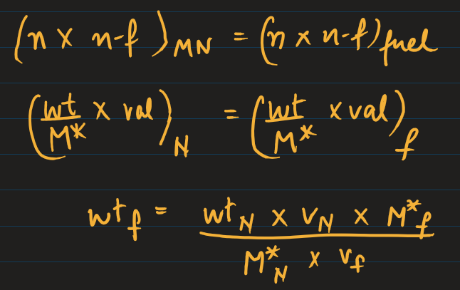
* Fuel Weight Calculation: Wt of urea = (5 × 10 × 60) / (256.41 × 6) = 1.95 g

Procedure

* Weigh 5.0 g Mg(NO3)2·6H2O and 1.95 g urea. (1:1 stoichiometry)
* Dissolve in 250 mL beaker with minimal distilled water.
* Stir 10 min using magnetic stirrer.
* Transfer to pre-heated furnace at 500°C.
* Observe gel formation followed by ignition and finally results in highly porous nano MgO formation.

Other Examples:

* Calculate the wt of fuel and write the combustion procedure for:
* 1. ZnO from Zn(NO₃)₂·6H₂O (Mol. Wt. = 297.49) using glycine (NH₂CH₂COOH, Mol. Wt = 75)
* Solution:
* 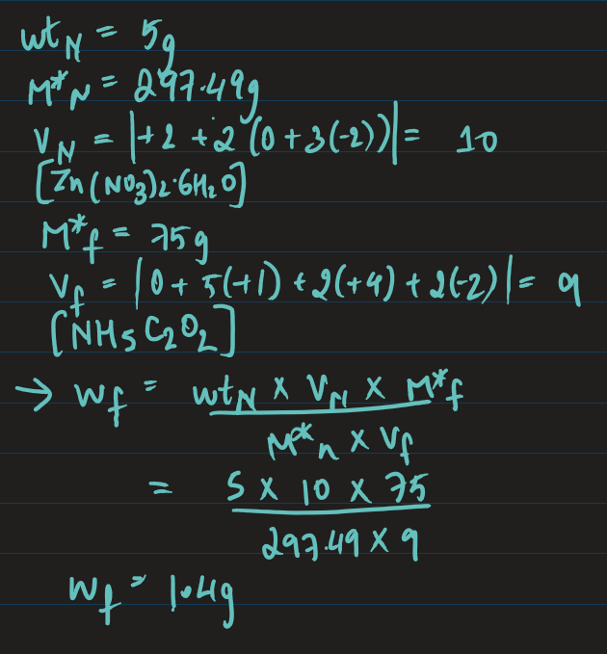
* 2. CaO from Ca(NO₃)₂·4H₂O (Mol. Wt. = 236.15) using glucose (C₆H₁₂O₆, Mol. Wt = 180)
* Solution: do it yourself

Sol-Gel Method

* Definition: A wet chemical technique used to fabricate nano-structured ceramic materials and thin films.
* Principle: Converts a precursor solution (usually metal alkoxides or salts) into a solid network of metal oxides through inorganic polymerization reactions catalysed by water /(hydrolysis and condensation, forming a gel).
* Precursor: Metal alkoxides (M-OR).
* Chemical Reactions:
* Hydrolysis: M-OR + H2O 🡪 M-OH + ROH
* Metal alkoxide reacts with water 🡪 Metal hydroxide + alcohol.
* Condensation:
* M-OH + M-OR 🡪 M-O-M + ROH
* Forms a polymeric network through M–O–M bonds (inorganic).

Sol-Gel Process Steps

* Step 1: Solution Preparation
* Dissolve metal salt or alkoxide in a solvent (often alcohol).
* Ensures a homogeneous solution.
* Step 2: Sol Formation by Hydrolysis
* Formation of colloidal sol through hydrolysis (nucleophilic attack by oxygen atom of water on -OR group).
* Sol is a stable dispersion of colloidal particles of precursors in a solvent
* Step 3: Gel Formation by Condensation
* Aging leads to condensation (M-O-M bonds).
* Forms rigid 3D gel network.
* Gel is an interconnected, rigid and porous inorganic network covered completely with liquid phase.
* The transformation is called sol-gel transition.
* Step 4: Drying of Gel
* Removes liq phase from gel network.
* Three methods:
* Supercritical drying (drying under high critical conditions) results in formation of Aerogel.
* Dehydration (removes ROH) results in Xerogel.
* Sintering at high temp (800°C) results in Powder (dense, decomposed network).
* Diagram of a diagram of gel drying

  AI-generated content may be incorrect.

Example: TiO₂ Preparation

* Chemical Used: Titanium isopropoxide. [Ti(O(CH(CH3)2)4)], alc, distilled water, HNO3
* Process:
* Dissolve Ti complex in ethanol + water (1:4).
* Add HNO3 to adjust pH and control hydrolysis.
* Stir for about 30 mins to form sol
* Keep to age for about a day to form gel.
* Dry at 120°C and sinter at 450°C to get TiO₂ nanoparticles.
* Mechanism: Nucleophilic attack by water on alkoxy group.

Advantage:

* Simple and economic.
* Highly flexible with stoichiometry & dopants.
* High-quality coatings.
* Inexpensive, pure precursors.
* Can produce various nanomaterial shapes.

Carbon Nanomaterials (CNTs)

* Definition: CNTs are cylindrical structures composed of a hexagonal network of carbon atoms (rolled-up graphene sheets).
* Types of CNTs:
* Single-Walled Nanotubes (SWNTs):
* Consist of a single graphene layer.
* Can be Armchair, Zig-Zag, or Chiral in structure.
* Multi-Walled Nanotubes (MWNTs):
* Made of multiple concentric graphene cylinders.
* Multiple rolled layers of graphene sheets.
* 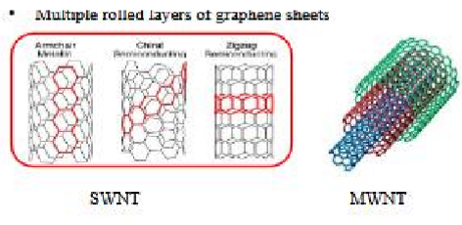

Synthesis of CNTs – Modified CVD Method

* Chemical Vapor Deposition (CVD) requirements:
* Furnace: High-temperature tubular furnace (500–1500°C).
* Carbon Source: Benzene, xylene, natural gas, acetylene.
* Substrate: Carbon, quartz, silicon.
* Inert Gases: Argon, Hydrogen, Nitrogen.
* Catalysts: Ferrocene, Nickelocene, Cobaltocene.

Exp setup

* Diagram of a heater with a diagram

  AI-generated content may be incorrect.
* A typical catalytic chemical vapour deposition system.
* Equipped with a horizontal tubular furnace as the reactor. The tube is made of quartz with diameter 30mm and length 1000mm.

Working

* Ferrocene acts as catalyst and benzene/toluene vapours acts as the carbon atom precursor which are transported to reaction chamber by inert gases like hydrogen, argon or both.
* This is decomposed into respective ions of Fe and carbon atoms resulting in carbon nanostructures.
* These nano structures grow into CNTs either in, before, or after the heating zone (typically 500–1150°C for ~30 minutes).

Mechanism of CNT growth

* Diffusion of hydrocarbon gas.
* Adsorption on catalyst active sites.
* Dissociation (homolytic fission) into C and H free radicals.
* Saturation via repetition of above steps.
* Precipitation of carbon atoms forms CNT structure and H radicals form H₂ gas.

Functionalization of CNTs

* CNTs naturally have poor dispersion in organic matrices. Functionalization improves compatibility and usability.
* a) Chemical (Covalent) Functionalization:
* Functional groups are covalently bonded to carbon atoms.
* Done at defect sites or end caps.
* Changes hybridization from sp² to sp³.
* Results in loss of π-conjugation but improves chemical reactivity.
* b) Physical (Non-Covalent) Functionalization:
* Uses π–π stacking or hydrophobic interactions.
* Maintains structural and electronic properties.
* functionalised non covalently by surfactants, polymers, aromatic molecules.
* A diagram of a chemical reaction

  AI-generated content may be incorrect.

Applications

* Field Emission Displays (FEDs).
* Electrodes for batteries, capacitors, fuel cells.
* Hydrogen storage in fuel vehicles.
* Artificial muscles, water splitting for H₂.
* Adsorbents for pollutants, photocatalysts.
* Sensors for metal ions, gases, biomolecules.
* Drug delivery systems.

Graphene

* Definition: Allotrope of carbon which is a single thick layer of carbon atoms arranged in a hexagonal lattice (sp² hybridized).
* Properties: Extremely strong, conductive, and flexible.
* Graphene Oxide (GO): Oxidized form of graphene with oxygen-containing groups (like –OH, –COOH, –O–) disrupting the conjugated π-network.
* Reduced Graphene Oxide (rGO): Partially restores the π-network by removing some oxygen groups from GO.

Synthesis: Modified Hummer’s Method

* Start: Graphite + NaNO3 + H2SO4 (in ice bath, stirred 30 min)
* Oxidation: Add KMnO4 to form graphite oxide
* Sonication at 50°C for 2 hrs and add H2O2 + Deionised water.
* Washing: Wash with HCl (10% and then 37%)
* Drying: gives GO powder
* Reduction: GO + NaBH4 (sodium borohydride) → rGO
* 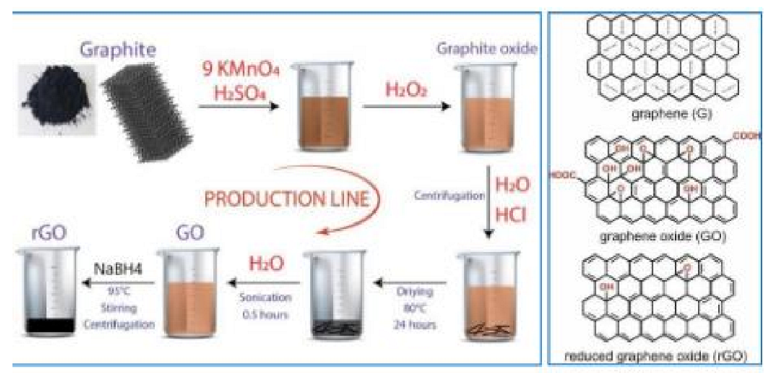

Functionalization of Graphene

* Reduces the cohesive force between graphene sheets and manipulate physical/chemical properties.
* Two types:
* Covalent (chemical bonds)
* Non-covalent (π–π stacking, electrostatic)
* Examples:
* Amine Functionalization:
* Using NH3 and NaHSO3 to bind amine groups to GO.
* A diagram of chemical formulas

  AI-generated content may be incorrect.
* Cysteine & Thiolene Functionalization:
* "Thiol-ene click" chemistry adds biomolecules to GO.
* A diagram of a molecule

  AI-generated content may be incorrect.
* Chemical Functionalization via carboxylic and hydroxyl groups for attaching drugs, dyes, or polymers.
* Graph graphene structure diagram with arrows

  AI-generated content may be incorrect.

Applications

* Electronics: Flexible screens, transistors, wearables
* Energy: Batteries, fuel cells, solar cells
* Medical: Drug delivery, cancer therapy, biosensors
* Sensors: UV, optical, chemical, biological
* Water Treatment: Desalination, purification
* Other: Lubricants, photothermal therapy, dialysis